Class 7

**Lecture 10**

**Web**

**Introduction to Web and its terminology.**

**Internet**

**&**

**Web**



**Lab Objectives:**

* Web
* Website and related info.

**What is Web?**

The World Wide Web (WWW) or simply a web is a network of online content that is formatted in HTML and accessed via HTTP. The term refers to all the interlinked HTML pages that can be accessed over the Internet.

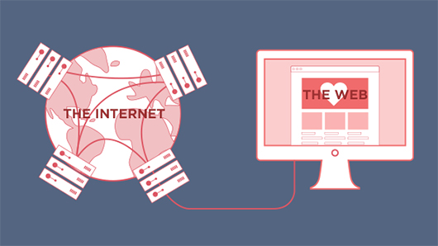

It is also a way of accessing information over the medium of the internet. It is an information-sharing model that is built on top of the internet. The web uses the HTTP protocol, only one of the languages spoken over the internet, to transmit data. Web services, which use HTTP to allow applications to communicate in order to exchange business logic, use the the web to share information. The web also utilizes browsers, to access Web documents called webpages that are linked to each other via hyperlinks. Web documents also contain graphics, sounds, text and video.

The World Wide Web was originally designed in 1991 by Tim Berners-Lee while he was a contractor at CERN. The World Wide Web is most often referred to simply as "the Web."

Domain name Hosting Browser. Web protocols:

**Website**

A website is a collection of related web pages, including multimedia content, typically identified with a common domain name, and published on at least one web server.

Notable examples are wikipedia.org, google.com, and amazon.com.

Today roughly 380 new websites are created every minute across the World

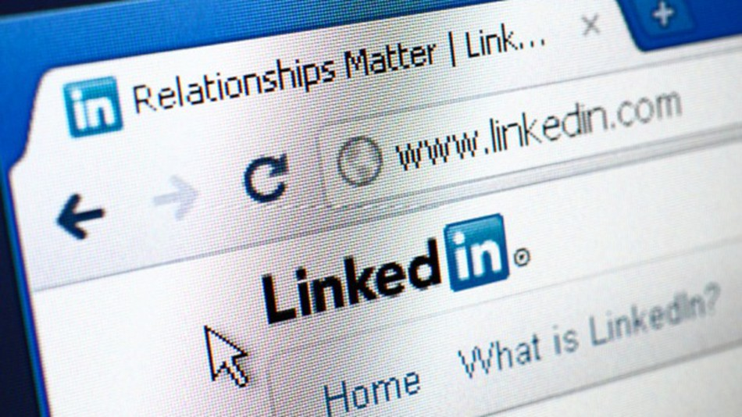

Websites uses

Generally, people look at websites for two primary reasons:

1. To find information they need. This could be anything from a student looking for pictures of frogs for a school project, to finding the latest stock quotes, to getting the address of the nearest Thai restaurant.

2. To complete a task. Visitors may want to buy the latest best-seller, download a software program, or participate in an online discussion about a favorite hobby.

**Webpage**

WebPages are the building block of Website. Website is made up with multiple webpage. The main webpage is known as Homepage for a website.

There are two type of websites based on its webpage’s behavior. They are-

* **Static**- Content is fixed.
* **Dynamic**- Content is responsive and may change.

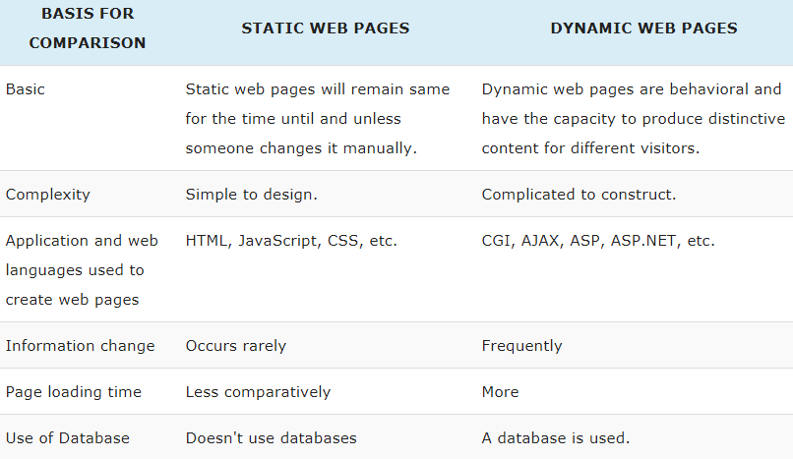

**Home Page**

Home Page itself a webpage. The central page of a website is called a home page. This is usually the first page you see when you call a website up and can also be called a ‘start page’ or ‘index page’. From here onwards, the user delves into the site’s subpages.

**Domain Name**

A domain name is a human friendly way to locate/define a website on internet. For example,www.google.com is a website address and google.com is the domain name of this website. Again facebook.com is the domain name of Facebook.

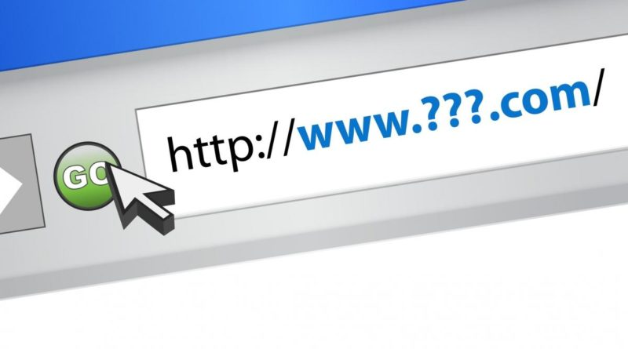

Every domain name has a suffix that indicates which top level domain (TLD) it belongs to. There are only a limited number of such domains. For example:

.gov - Government agencies

.edu - Educational institutions

.org - Organizations (nonprofit)

.mil - Military

.com - commercial business

.net - Network organizations

.ca - Canada

.th – Thailand

.bd-Bangladesh

**Web server**

A computer that hosts a website on the Internet.